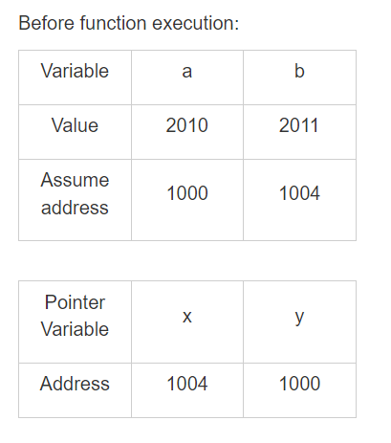

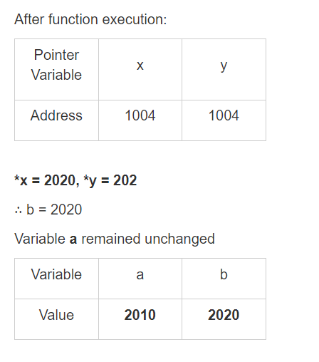

\*x = 2020 //from function definition

Therefore, \*y= 2020

Therefore, b = 2020 but Variable a remained unchanged

Therefore options 1, 3, and 4 are correct.